**USER MANUAL**

|  |  |
| --- | --- |
| **Table of Contents** |  |
| **Page** |  |
| What is Kroy? …………………………………………………………………………... | 2 |
| System Requirements …………………………………………………………………. | 2 |
| Controls …………………………………………………………………………………. | 2 |
| Characters and Obstacles …………………………………………………………….. | 3 |
| The Game Screen …………………………………………………………………….... | 4 |
| The Game Levels ………………………………………………………………………. | 4 |
| Other Screens …………………………................................................................... | 5 |
| Resetting the Game ……………………………………………………………………. | 8 |

**What is Kroy?**

Kroy is a single-player game set in the year 2042 where evil extraterrestrials (ETs) from the planet Kroy have invaded York, taking hold of key locations in the city and making life miserable for the citizens. It is your job to take back the city and liberate the citizens by eliminating the ETs and destroying their fortresses.

While these ETs may have very advanced weaponry, they have ONE weakness. Water. You will take up base in a fire station and use the fire trucks at your disposal to flood the enemy fortresses and evaporate any ETs in your way.

ET patrols, your health and the amount of water in your fire truck will mean you have to strategically evaluate your route to the fortress using stealth and courage. There are six levels available, allowing you to explore the beautiful city of York, as you progress through these levels you will encounter increasing levels of difficulty, however you will have access to four fire trucks to combat the ETs and their fortresses.

When you run out of water, or running low on health, you will need to head back to the fire station for some repairs or to refill your water tank. In higher levels, you fire stations location may be compromised, so be ready to defend your base. If all of your fire trucks are destroyed, the game is lost and you must go back to the start of the game.

**System Requirements**

Windows or linux

Aspect ratio: the game has a fixed aspect ratio of 1920x1080

**Controls**

**Movement**

W - Forward

A - Left

S - Backward

D - Right

**Attack**

Space - Attack

Mouse - Aim

**Other**

Mouse Button 1 - Selects Firetruck and is used to click ……………………………………………………... and interact with buttons

Esc - goes to pause menu

Enter - Exit ‘won’/’lost’ popups

**Characters and Obstacles**

**Firetruck 1**

A heavy defensive fire truck which is able to tank damage to get through difficult scenarios. This fire truck has the highest health of all the fire trucks but suffers from a low water supply and a slow speed.

**Firetruck 2**

This fire truck is equipped with the highest water quantity, thereby minimizing the amount of trips between the firestation and the enemy base, and has a low health value.

**Flying Saucer**

A basic enemy which moves between two points and fires a deadly shot when any fire trucks enter its radius. Each alien is unique with its own health value and damage output.

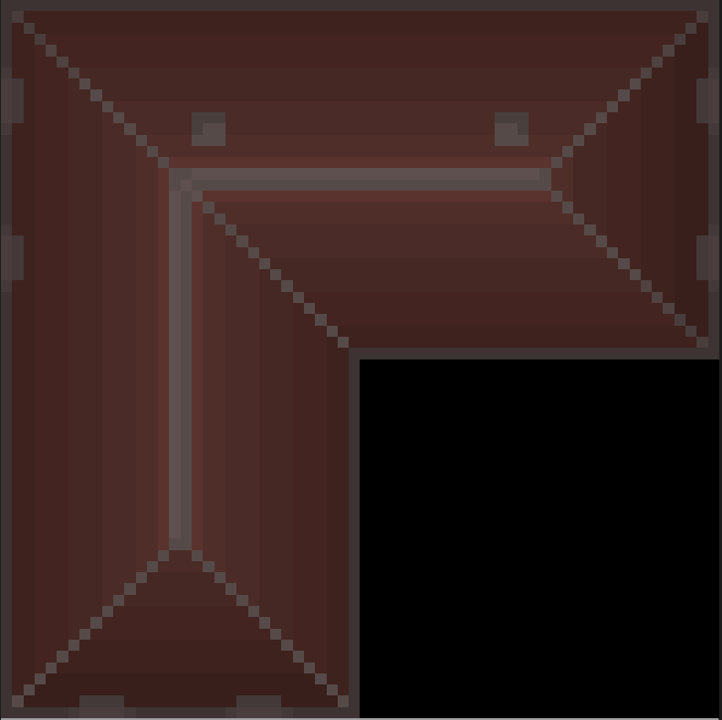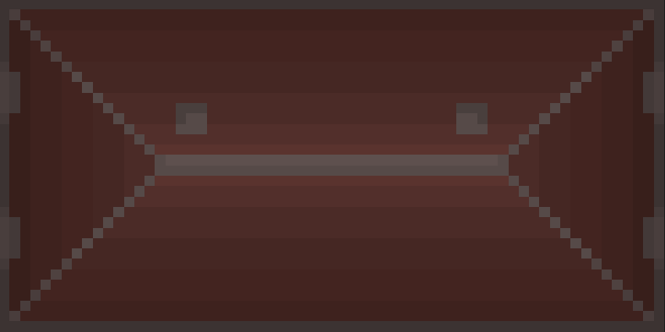

Building type 1 Building type 2

Each map contains immovable obstacles, denoted by buildings, water textures (only in the second level), and castle wall textures (only in the third level).

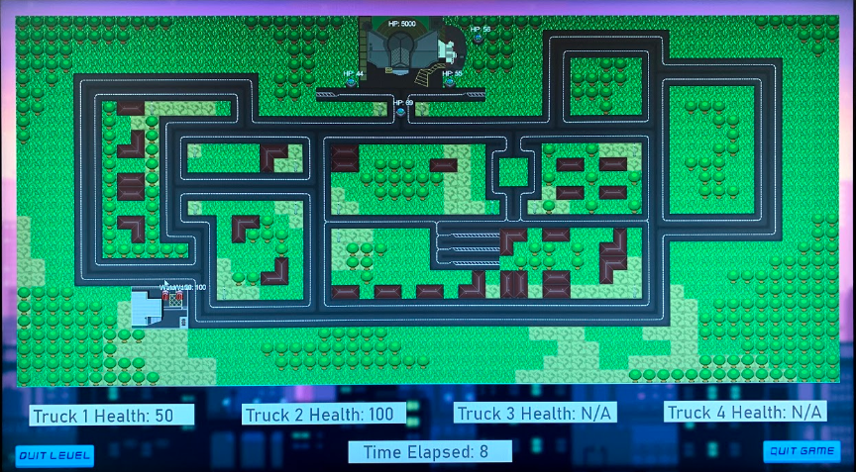

**The Game Screen**

The game screen is the window of the program that the user is directed to after selecting a level. Taking up most of the screen is the map where under it lies 4 health bars (allowing for up to 4 playable fire trucks) and the timer. Within the map, the health of the aliens is located above them, this is also consistent with the fire trucks, except instead of their health above them, it is their water content. In the final closing seconds of the game, pop ups for time, such as ‘15 seconds left’ may be visible in the top right corner of the map to notify the user.

When the user has either won or lost the level, they are notified by a ‘won’ or ‘lost’ popup which they can exit using the ‘enter’ key, returning them to the level selection screen.

**The Game Levels**

Description of the levels

**Level 1**

The evil aliens have resided their fortress within the Barbican Theater. You must seek out and fend off this menace to save the fire station from impending doom.

**Level 2**

The Central Hall has been claimed by the alien forces. Go forth and save central hall and York University from their clutches. Navigate around the deep lake of York University and make your brave stand against the aliens.

**Level 3**

The aliens have taken over the York Minster as their final stand. Navigate past the walls of the York Minster and finally wipe these aliens out for good.

**Other Screens**

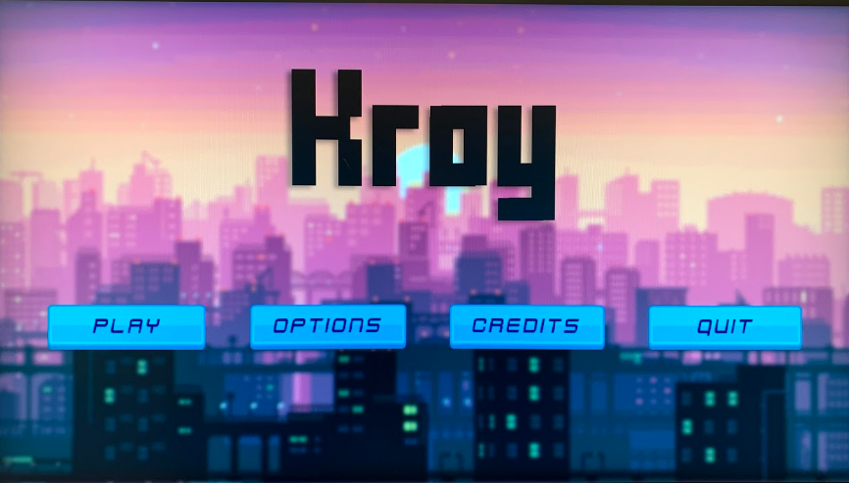

**Main Menu**

The Main Menu screen contains 4 buttons:

* Play - directs the user to the level select screen
* Options - directs the user to the options screen
* Credits - directs the user to the credits screen
* Instructions - directs the user to a page containing instructions
* Quit - quits the program

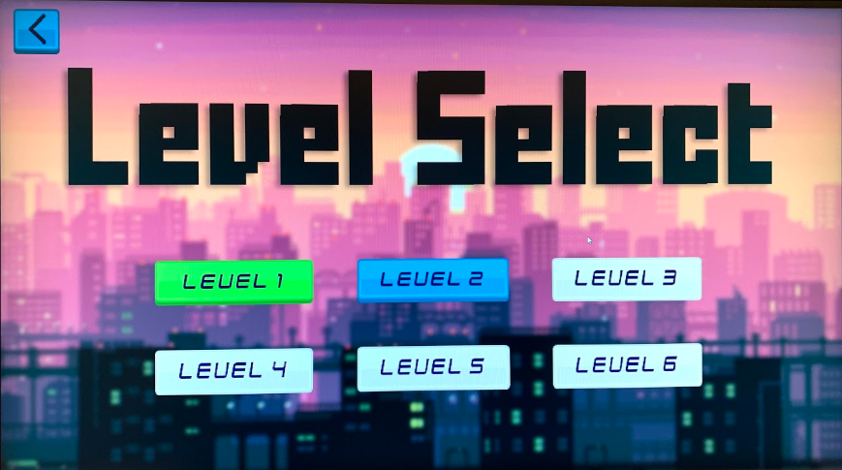

**Level Selection Screen**

This screen allows the user to select a level to play. However they can only select levels depending on whether they have completed the previous level. The first level is unlocked by default. This screen contains 7 buttons, 6 buttons for the six different levels (however only 3 have been implemented so far), and the 7th button as the back button which returns the user to the Main Menu.

Each of the level buttons can be one of three colours:

* Grey - locked, as the player hasn’t completed the previous level
* Green - completed
* Blue - selected

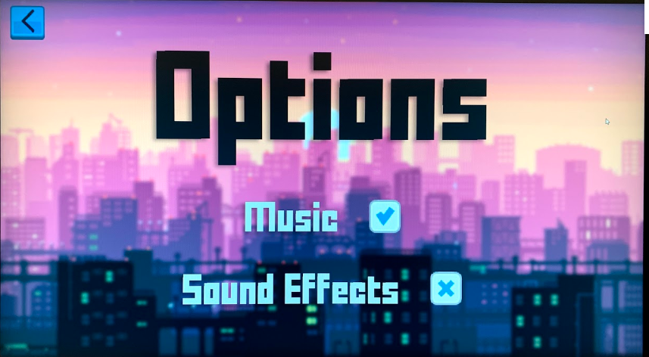

**Options Screen**

Sound effects On/Off: disables or enables sound effects in the game

Music On/Off: disables or enables music in the game

Back button: returns to the main menu

**Pause screen**

Sound effects On/Off: disables or enables sound effects in the game

Music On/Off: disables or enables music in the game

Back button: returns to the game with all progress continuing as normal

**Lost pop-up**

There are multiple ways of losing, having no more fire trucks as they are all destroyed or the timer is at 0. In both cases, a ‘lost’ pop-up appears which can be exited via pressing the ‘enter’ key, directing the user back to the ‘Level Selection’ screen.

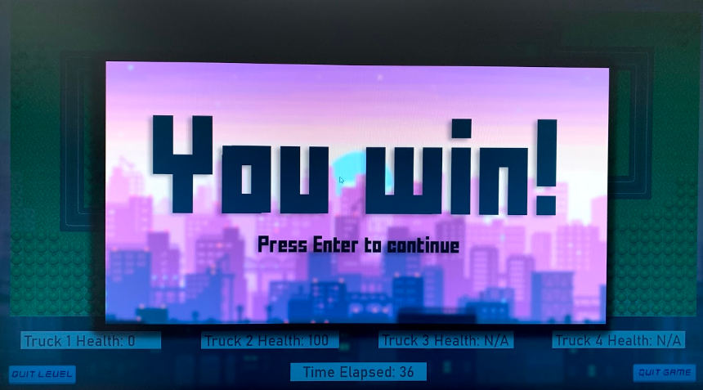

**Win pop-up**

The user wins by destroying the enemy fortress, once this happens, the ‘win’ pop-up appears on the screen and can be exited by pressing the ‘enter’ key, directing the user back to the ‘Level Selection’ screen.

**Resetting the Game**

In order to reset the game, the user must delete their preferences file stored in their game folder. To locate this file, identify your operating system, and go to the following locations:

|  |  |
| --- | --- |
| **OS** | **Preferences Storage Location** |
| Windows | %UserProfile%/.prefs/Kroy |
| Linux | ~/.prefs/Kroy |